

***CONFIGURATION MANAGEMENT***

***FOR***

***Residential Communication Channel System***

***Version 1.3***

***Team 2 - GENTLEMAN***

***Revision***

|  |  |  |  |
| --- | --- | --- | --- |
| *Author* | *Version* | *Date* | *Content* |
| *Hau Vo* | ***1.1*** | *24/10/2018* | *Initiate Document* |
| *Hau Vo* | ***1.2*** | *25/10/2018* | *Update Content Document* |
| *Vinh Nguyen* | ***1.3*** | *26/10/2018* | *Review and Update Document* |

Table of Contents

***1.*** ***Document Overview*** 1

***a.*** ***Purpose*** 1

***b.*** ***Audience*** 1

***c.*** ***Glossary*** 2

***2.*** ***Configuration Management*** 2

***a.*** ***Tools, Environment and Infrastructure*** 2

***b.*** ***Configuration Items*** 2

***c.*** ***Code Standards*** 3

***d.*** ***Configuration for Document Abbreviation Name*** 3

***e.*** ***Tools for storage and acess to repository*** 4

***f.*** ***Document and Source Code repository*** 4

***g.*** ***Tools for editing document*** 4

***3.*** ***Folder Management*** 4

***a.*** ***Folder for Project*** 4

***b.*** ***Folder for Personal*** 4

***c.*** ***Folder for Meeting Minute and Template*** 4

***4.*** ***Configuration Report and Audit*** 4

***5.*** ***Reference*** 4

1. ***Document Overview***
   1. ***Purpose***
      * This document serves as a standard for team members throughout the project. The document details the product implementation standards, specifications, and product development environment.
   2. ***Audience***

|  |  |  |
| --- | --- | --- |
| **Intended Audience** | **Name** | **Reading Suggestions** |
| GENTLEMAN – Team Member | * Manh Truong * Quan Ngo * Hao Vo * Lam To * An Pham | Review Document and report |
| Mentor | * Quoc Nguyen | Review Document |
| Project Manager | * Vinh Nguyen | Initiate and Document Specification |

* 1. ***Glossary***

|  |  |  |
| --- | --- | --- |
| **No.** | **Name of Glossary** | **Desciption** |
| *1.* | RCC | Residential Communication Channel System |
| *2.* | CIs | Configuration Items |
| *3.* | CM | Configuration Management |

1. ***Configuration Management***
   1. ***Tools, Environment and Infrastructure***

|  |  |  |
| --- | --- | --- |
| **No.** | **Tools** | **Description** |
| *1.* | Microsoft Office 2016 | Use to develop document, text editor, plan, schedule |
| *2.* | Microsoft Visio 2013 | Use to develop processes. |
| *3.* | Sublime Text 3 | Use to develop Mobile platform |
| *4.* | Android Studio | Use to support for develop Mobile |
| *5.* | Microsoft OneDrive | Use to store document |
| *6.* | Visual Studio 2017 | Use to develop Web platform |
|  |  |  |
|  |  |  |

* 1. ***Configuration Items***

|  |  |  |  |
| --- | --- | --- | --- |
| **No.** | **Category** | **Items** | **Item List** |
| *1.* | Document | Project Management | Name rule, font, size, color, content, revision.  In progress version (Ex: ver 1.1, ver1.2,…  Baseline version (Ex: ver1.0, ver2.0**)** |
| Requirement |
| Architecture and Design |
| Development |
| Testing |
| Quality & Process Management |
| *2.* | Drawing Development | Sequence Diagram | Symbols Standard for drawing |
| Context Diagram |
| Use Case |
| Class Diagram |
| Activity Diagram |
| *3.* | Development Tools | Develop Product | Sublime Text, Visual Studio,Nodejs, Robo3T . MS sql Server, Genymotion |
| Drawing | Microsoft Visio, iMindmap |
| Document | Microsoft Word, Excel |
| Management | Microsoft Excel, Word |
|  |  |  |  |

* 1. ***Code Standards***

|  |  |  |  |
| --- | --- | --- | --- |
| **No.** | **Variable** | **Regulations** | **Field** |
|  |  |  |  |
|  |  |  |  |
|  |  |  |  |
|  |  |  |  |
|  |  |  |  |

* 1. ***Configuration for Document Abbreviation Name***

|  |  |  |  |
| --- | --- | --- | --- |
| **No.** |  | **Process Name** | **Document Abbreviation** |
| *1.* |  | Project Management | PM |
| *2.* |  | Requirement | RE |
| *3.* |  | Architecture & Design | AD for Architecture Design  DD for Detail Design |
| *4.* |  | Development | DE |
| *5.* |  | Testing | TE |
| *6.* |  | Process & Quality Management | PQ |

***<Name of document> = <Name of project>_<Document Abbreviation>_<Name>_<X.X>***

* ***Name of project:*** is name of project
* ***Document Abbreviation:*** is Abbreviation of document in process
* ***Name:***  is the name of document
* ***X.X:*** is version of document ( ver 0.1, ver 0.2… )

*Ex: C*onfiguration management document of Residential Communication Channel System has name:

* *RCC_PM_ConfigurationManagement_ver 1.0*

*Note: For the meeting minute and effort log:*

* *Meeting minute with customer:*

*RCC_MeetingMinutes_Customer_Date*

* *Meeting minute with mentor:*

*RCC_MeetingMinutes_Mentor_Date*

* *Meeting minute with team:*

*RCC_MeetingMinutes_Team_Date*

* *Effort log:*

*RCC_EffortLog_FirstName_LastName_Date*

* 1. ***Tools for storage and access to Document repository***

|  |  |  |
| --- | --- | --- |
| **No.** | **Name** | **Desciption** |
| *1.* | Github Desktop | Tool in PC help team can manage source code or document |
| *2.* | Github URL | <https://github.com/sonvinh/GENTLEMAN_CAPSTONE_DOCUMENT> |

* 1. ***Tools for storage and access to Source Code repository***

|  |  |  |
| --- | --- | --- |
| **No.** | **Name** | **Desciption** |
| *1.* |  |  |
| *2.* |  |  |

* 1. ***Tools for editing document***

|  |  |  |
| --- | --- | --- |
| **No.** | **Name** | **Desciption** |
| *1.* | Microsoft Word 2016 | Tool used for edit content of document with word format |
| *2.* | Microsoft Excel 2016 | Tool used for edit content of document with excel format |

1. ***Folder Management***
   1. ***Folder for Project***

*First, acess to GENTLEMAN_CAPSTONE_DOCUMENT:*

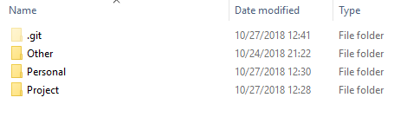

*Choose Project Folder :*

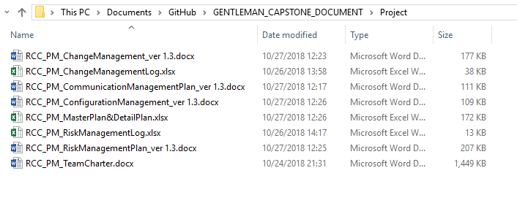

* 1. ***Folder for Personal***

*First, acess to GENTLEMAN_CAPSTONE_DOCUMENT:*

**

*Choose Personal Folder :*

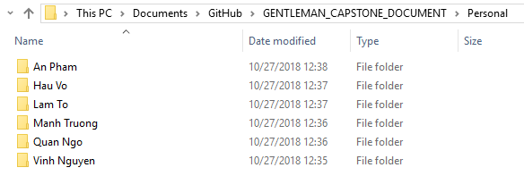

* 1. ***Folder for Meeting Minute and Template***

*First, acess to GENTLEMAN_CAPSTONE_DOCUMENT:*

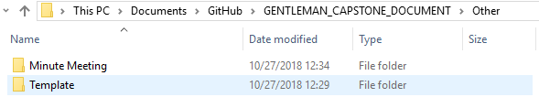

1. ***Configuration Report and Audit***

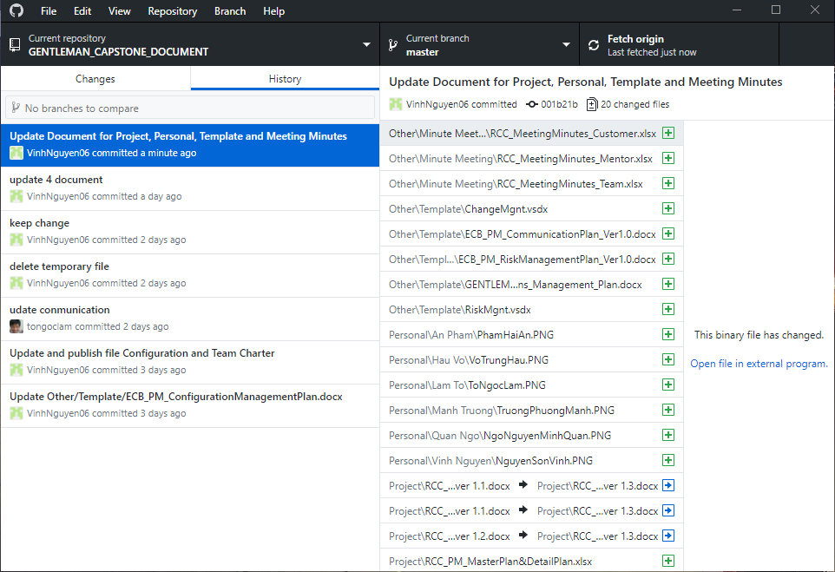

1. ***Reference***